**INITIALIZING SPRING PROJECT**

**FILES STRUCTURE**

**CountryController.java**

package com.cognizant.spring_learns.country_service2.controller;

import com.cognizant.spring_learns.country_service2.model.Country;

import com.cognizant.spring_learns.country_service2.service.CountryService;

import org.springframework.beans.factory.annotation.Autowired;

import org.springframework.web.bind.annotation.*;

*@RestController*

public class CountryController {

*@Autowired*

private CountryService countryService;

*@GetMapping*("/countries/{code}")

public Country getCountry(*@PathVariable* String code) {

return countryService.getCountry(code);

}

}

**Country.xml**

<beans xmlns="http://www.springframework.org/schema/beans"

xmlns:xsi="http://www.w3.org/2001/XMLSchema-instance"

xsi:schemaLocation="http://www.springframework.org/schema/beans

https://www.springframework.org/schema/beans/spring-beans.xsd">

<bean id="in" class="com.cognizant.spring_learns.country_service2.model.Country">

<property name="code" value="IN" />

<property name="name" value="India" />

</bean>

<bean id="us" class="com.cognizant.spring_learns.country_service2.model.Country">

<property name="code" value="US" />

<property name="name" value="United States" />

</bean>

<bean id="de" class="com.cognizant.spring_learns.country_service2.model.Country">

<property name="code" value="DE" />

<property name="name" value="Germany" />

</bean>

<bean id="jp" class="com.cognizant.spring_learns.country_service2.model.Country">

<property name="code" value="JP" />

<property name="name" value="Japan" />

</bean>

<bean id="countryList" class="java.util.ArrayList">

<constructor-arg>

<list>

<ref bean="in"/>

<ref bean="us"/>

<ref bean="de"/>

<ref bean="jp"/>

</list>

</constructor-arg>

</bean>

</beans>

**CountryServiceImpl.java**

package com.cognizant.spring_learns.country_service2.service;

import com.cognizant.spring_learns.country_service2.model.Country;

import org.springframework.context.support.ClassPathXmlApplicationContext;

import org.springframework.stereotype.Service;

import java.util.List;

*@Service*

public class CountryServiceImpl implements CountryService {

*@Override*

public Country getCountry(String code) {

try (ClassPathXmlApplicationContext context = new ClassPathXmlApplicationContext("country.xml")) {

List<Country> countries = (List<Country>) context.getBean("countryList");

return countries.stream()

.filter(c -> c.getCode().equalsIgnoreCase(code))

.findFirst()

.orElse(null);

}

}

}

**Country.java**

package com.cognizant.spring_learns.country_service2.model;

public class Country {

private String code;

private String name;

public Country() {}

public String getCode() {

return code;

}

public void setCode(String code) {

this.code = code;

}

public String getName() {

return name;

}

public void setName(String name) {

this.name = name;

}

}

**CountryService2Application.java**

package com.cognizant.spring_learns.country_service2;

import org.springframework.boot.SpringApplication;

import org.springframework.boot.autoconfigure.SpringBootApplication;

@SpringBootApplication

public class CountryService2Application {

public static void main(String[] args) {

SpringApplication.run(CountryService2Application.class, args);

}

}

**OUTPUTS AFTER RUNNING THE PROJECT**

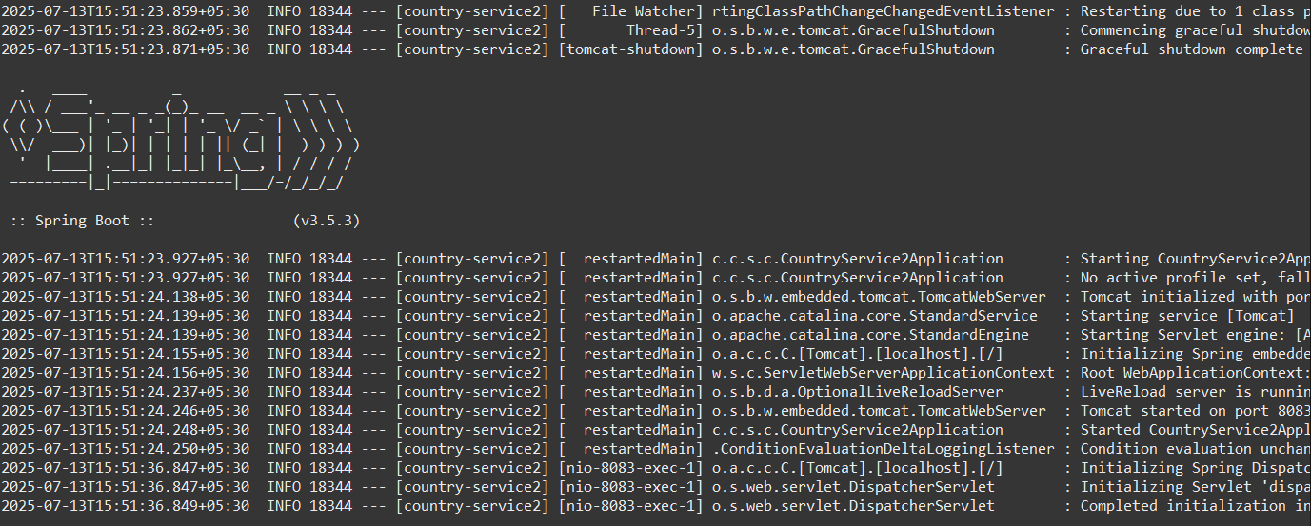

**//IMPLEMENTING IN LOCAL HOST TO RETRIEVE THE DATA USING SEARCHING METHOD BY ID**

